Databases and SQL

**Problem 1: Find the total number of records for each of the 3 tables**

Take a screenshot showing the 3 SQL queries and their results. Upload the JPEG (.jpg) file below for your peers to review.

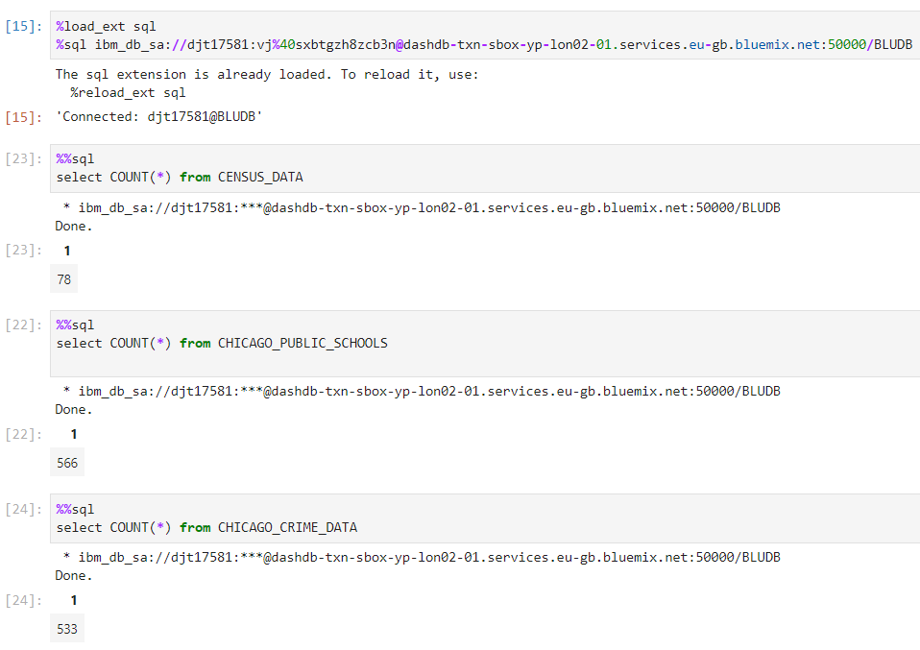

**Problem 2: Find average college enrollments by community area**

Take a screenshot showing the SQL query and its results. Upload the JPEG (.jpg) file below for your peers to review.

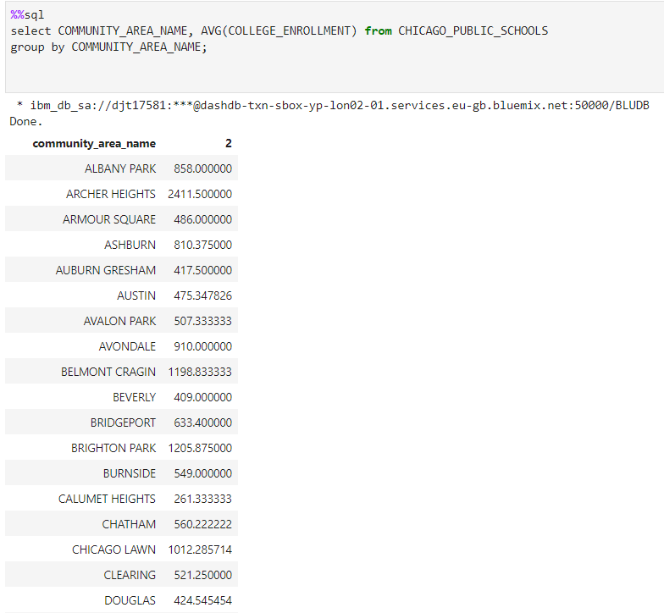

**Problem 3: Find the number of schools that are healthy school certified**

Take a screenshot showing the SQL query and its results. Upload the JPEG (.jpg) file below for your peers to review.

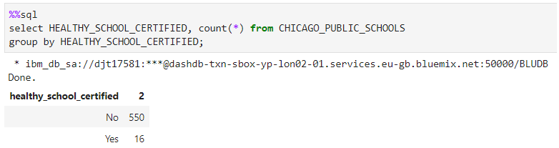

**Problem 4: How many observations have a LocationDescription value of GAS STATION?**

Take a screenshot showing the SQL query and its results. Upload the JPEG (.jpg) file below for your peers to review.

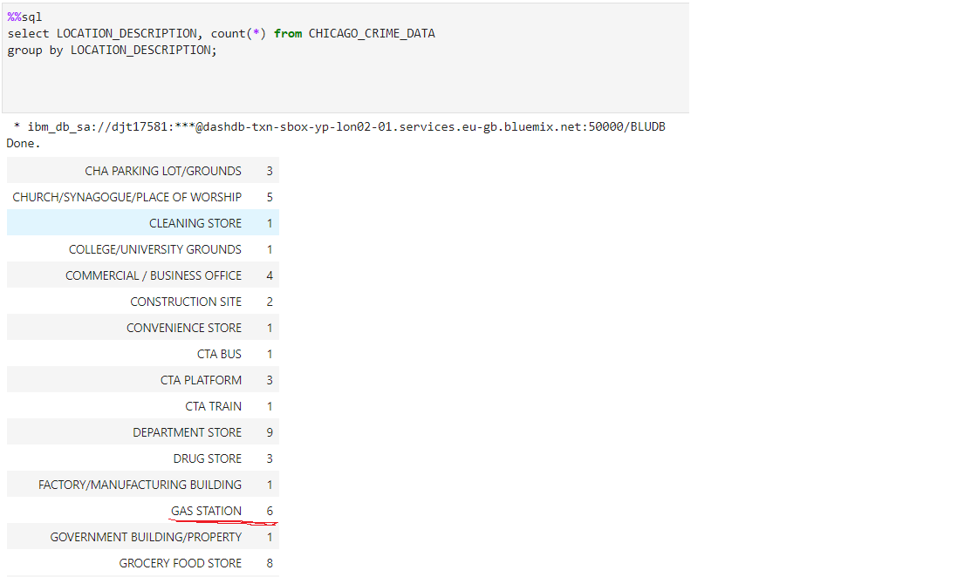

**Problem 5: Retrieve a list of the top 10 community areas which have most number of schools and sorted in descending order.**

Take a screenshot showing the SQL query and its results. Upload the JPEG (.jpg) file below for your peers to review.

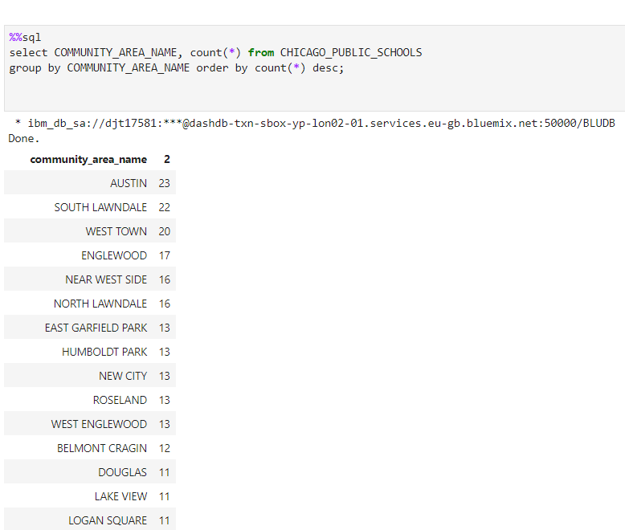

**Problem 6: How many observations have value MOTOR VEHICLE THEFT in the Primary Type variable (this is the number of crimes related to Motor vehicles)**

Take a screenshot showing the SQL query and its results. Upload the JPEG (.jpg) file below for your peers to review.

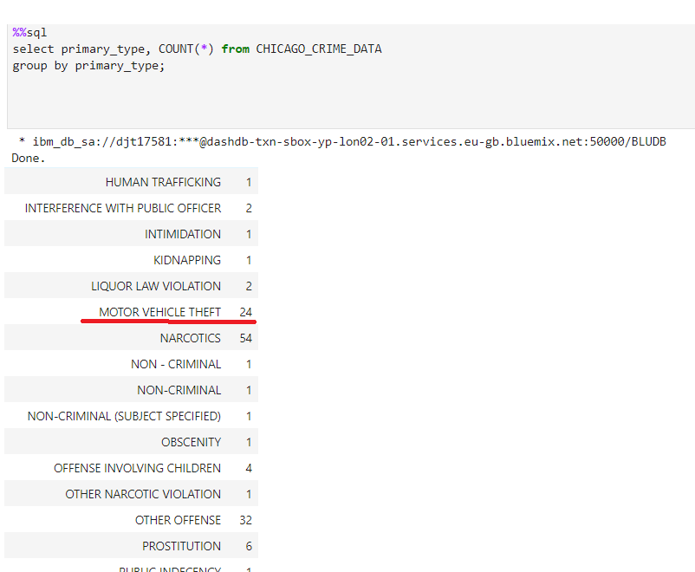

**Problem 7: Find the minimum “Average Student Attendance” for community are where hardship is 96**

Take a screenshot showing the SQL query and its results. Upload the JPEG (.jpg) file below for your peers to review.

